17.Write a Pandas program to split the following dataframe by school code and get
mean, min, and max value of age for each school.
Aim:
To write a Pandas program to split a DataFrame by school code and find the mean, minimum, and maximum age for each school.
Program:
import pandas as pd

data = pd.DataFrame({
"school_code": ["S001", "S002", "S001", "S003", "S002", "S001"],
"student_name": ["Ravi", "Anu", "Kiran", "Meena", "Rahul", "Divya"],
"age": [15, 16, 14, 17, 15, 16]
})
result = data.groupby("school_code")["age"].agg(["mean", "min", "max"])
print(result)
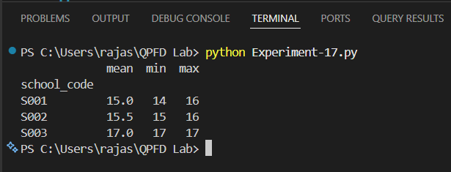
Output:
Result:
The program successfully grouped the students based on school code and calculated the mean, minimum, and maximum age for each school.

18.Write a Pandas program to split the following given dataframe into groups based on
school code and class.
Aim:
To write a Pandas program to split a DataFrame into groups based on school code and class.
Program:
import pandas as pd

data = pd.DataFrame({
"school_code": ["S001", "S001", "S002", "S002", "S001", "S003"],
"class": ["10A", "10B", "10A", "10B", "10A", "10A"],
"student_name": ["Ravi", "Anu", "Kiran", "Meena", "Rahul", "Divya"],
"age": [15, 16, 15, 16, 15, 17]
})
group = data.groupby(["school_code", "class"])
for name, details in group:
print("\nGroup:", name)
print(details)
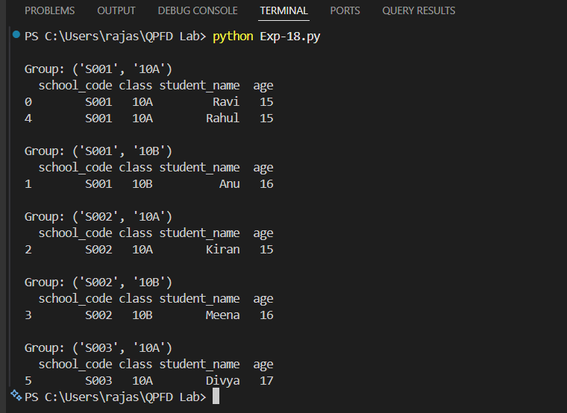
Output:

Result:
The program successfully split the DataFrame into groups based on school code and class using the groupby() function.

